

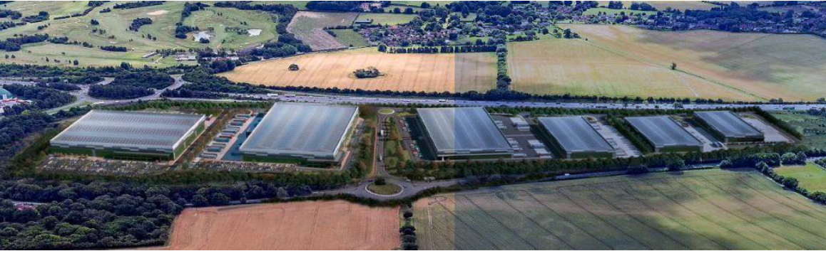
A30 Warehouses - Your countryside needs you to OBJECT AGAIN!

Following our recent message, we have now reviewed in detail the 80+ documents of amendments submitted by the developers.

We find that little has changed since the previous applications going back to 2021.

This would still be a huge blot on the Hampshire countryside. It is the wrong development in completely the wrong place.

The developers have deep pockets and will not easily give up their option to develop the land. All four previous proposals have been refused including an appeal to the Government Planning Inspector late in 2022.

We now urgently need to make it clear yet again that this is an unacceptable development.

We don’t yet know when this application will be put before Basingstoke’s Development Control Committee, but the Planning Officers have given a deadline of 20th July for objections to be submitted.

It is unfortunate that Newlands choose the busiest times of the year to submit their applications (the previous was Christmas 2023). A General Election, football, Wimbledon, and holidays are distractions right now but please take time to let our planners know what you think. You may simply re-submit an earlier objection or raise other points. If it helps, the list below is a reminder of the main issues.

You may submit your objection by simply clicking here https://planning.basingstoke.gov.uk/online-applications/ and entering 23/03120/FUL in the search box. Remember, family members may also submit objections.

Thank you!

CAGE
Reasons for objecting to this development

LANDSCAPE AND VISUAL IMPACT

- Cited by planning inspector as main reason for rejecting the appeal in October 2022
- The buildings are ugly / unattractive, functional, and completely out of keeping with the area. Unit 2 has been enlarged in the latest application. It would now be more visible from several viewpoints including from Dummer’s Recreation Ground.
- The many changes to the plans are insufficient to mitigate the impact of this development on the locality. It severely degrades the character of the local downland area.
- It is outside the Settlement Policy Boundary which presumes no development of this type.
- It makes for a very poor and unattractive gateway to Basingstoke.
- This is a 1km long development of 80+ feet high warehouses in a rural landscape. It will be highly visible from footpaths and only 200-300m from the nearest residential estates.

TRAFFIC

- There will be a significant increase in HGV traffic as well as traffic from employees.
- This traffic will inevitably use local roads as shortcuts to avoid congestion. North Waltham, Dummer, Hounsome Fields are particularly at risk
- Overnight parking of HGVs in local roads is highly likely given limited capacity on site

IMPACT OF LIGHTING ON DARK SKIES AND THE ENVIRONMENT

- There will be a significant impact on the area’s dark skies from the lighting requirements for the warehouse units.
- Planned lighting will compromise the wildlife corridor to the detriment of bats and other local wildlife.
- The latest plans have actually increased the quantity of lighting units. It is impossible to mitigate this completely.

NO NEED, NO BUSINESS CASE
- The economic justification is unclear. There is no clear business case other than an apparent regional need for more warehouse and distribution space.
- Employment is cited as a benefit, but Basingstoke cannot source the staffing numbers. With 1,000+ vacancies in this sector in Basingstoke today, the warehouses will be staffed by commuting into the site.
- Good planning is not just about creating jobs, it is about creating the right jobs.
- Do we really want a vast collection of regional warehouses to be one of the primary gateways to Basingstoke?

LOSS OF GRADE 3 ARABLE FARMLAND

- In today’s climate it makes no environmental sense to concrete over 100+ acres of prime farmland.
- Inevitably this has to have an impact on food security.

DANGER TO PROTECTED TREES
- Installation of subterranean culverts and pipes from site to drain run-off from acres of roofing and hard standing to holding ponds will significantly impact the protected avenue of trees.
- Over 20 mature trees are to be felled (more than 25% of all trees on the site), 9 of which are mature English Oaks and 8 of which are considered by the BDBC Tree Officer to have been inadequately graded by the applicant and should be re-graded as being of the highest category. It is also proposed to remove a further 5 groups of trees one of which is admitted by the applicant to be of the highest arboriculture standard.

THE FUTURE HOSPITAL
- The Oakdown Farm site is directly opposite the preferred location of the new Basingstoke hospital.
- This would look incongruous and potentially add delays and complications to plans for the hospital if approved.
- Congestion and HGV conflicts with emergency vehicles will inevitably result.
- 24/7 operation of the warehouses with the associated lighting and noise will create significant disturbance.
- Any or all of the above could jeopardise plans and timing for the new hospital.

